This diagram shows how the ground below the water table (the blue area) is saturated with water. The "unsaturated zone" (zone of aeration) above the water table (the greenish area) still contains water (after all, plants' roots live in this area), but it is not totally saturated with water. You can see this in the two drawings at the bottom of the diagram, which show a close-up of how water is stored in between underground rock particles.
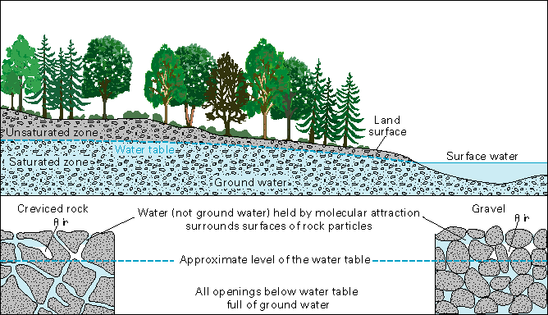
Information on this page is from Waller, Roger M., Ground Water and the Rural Homeowner, Pamphlet, U.S. Geolgoical Survey, 1982

