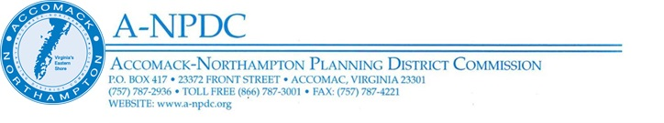

RFP Engineering Annual Services Contract – Advertised April 19, 2024
Questions and Answers

The following provides answers to questions received:
- Question: What data is currently available to conduct the preliminary hydraulic analysis?
Answer: Rail corridor surveys conducted by right-of-way owner Canonie Atlantic Company, Accomack County, HRSD, and VDOT may document current drainage assets, including culverts and other hydraulic infrastructure.

- Question: Could you please clarify how 6.6 will be evaluated?
Answer: Section 6.6 is one of six criteria that will be used for proposal evaluation. It is worth 10% of the total evaluation criteria. Specifically, 6.6 asks proposers to list the subconsultants and subcontractors whom the proposer may employ to perform work on the Eastern Shore Rail Trail. A-NPDC is looking for the names of proposed subconsultants and subcontractors who are in good standing and who are eligible to participate in the design and construction of the Eastern Shore Rail Trail.
Proposers will take due notice and be governed accordingly. All other terms and conditions remain the same.
For the Accomack-Northampton Planning District Commission,
Anne Doyle, Director of Planning
23372 Front Street
Accomac, Virginia 23301
Phone: 757-787-2936, ext. 115
Email: adoyle@a-npdc.org

