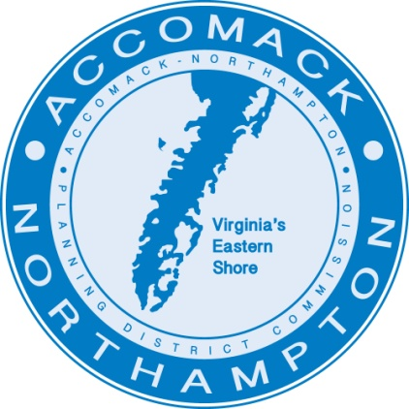
Full Job Description:
Community Development Coordinator
Status: Full-Time/Salaried Hiring Range: $45,000 to $55,000
Reporting Responsibility: This position reports to the Director of Housing
Development
Location: Accomac, Virginia
Review of applications will begin December 1, 2025 and continue until filled.

The Accomack-Northampton Planning District Commission (A-NPDC), a regional non-profit organization based in Accomac, Virginia, seeks a motivated person to provide project management for various state and federal construction and planning activities. With the A-NPDC’s fast-growing diversity of programs, this is an exciting opportunity for a creative and driven professional to gain experience and have their efforts make a positive impact on the communities of the Eastern Shore of Virginia.
About the A-NPDC:
The A-NPDC has been the Eastern Shore of Virginia’s regional planning organization since 1970. Created by the Commonwealth of Virginia, the County of Accomack and the County of Northampton and joined by the Town of Chincoteague, the A-NPDC is tasked with supporting local planning and community development efforts and providing technical assistance on behalf of the Commonwealth. The A-NPDC focuses on issues of regional importance by working with local, state, and federal governments.
The Commonwealth of Virginia is divided into 21 planning districts based on communities of interest among its counties, cities and towns. The purpose of planning districts as described in the Code of Virginia is to:
- Encourage and facilitate local government cooperation and state-local cooperation in addressing problems of greater than local significance;
- Facilitate the recognition and analysis of regional opportunities; and
- Promote the orderly and efficient development of the physical, social and economic elements of the district by assisting localities plan for the future.
The primary mission of the A-NPDC is to respond to local government requests for assistance in planning for and managing growth in the region. This includes:
- Helping local governments develop policies, plans and regulations to manage growth and development;
- Helping local governments develop affordable housing and healthy communities;
- Helping local governments with the protection and wise use of natural resources;
- Bringing emerging issues of regional importance to the attention of local government;
- Facilitating problem solving by convening appropriate stakeholders and identifying sources of funding;
- Assisting with outreach to local citizens on issues of regional and local concern;
- Providing technical assistance on specific planning activities as requested by localities; and
- Helping to implement regional plans and administer regional programs at the request of the localities.
Every PDC in the Commonwealth is a unique expression of its region. For the Eastern Shore of Virginia (ESVA), the A-NPDC has been tasked with improving housing quality, seeking, financing and building community development projects and providing structure to regional and community goals.

Job Description:
The position of Community Development Coordinator is classified as a technical position that focuses on implementing community development projects with an emphasis on housing, community, and economic revitalization. This individual will be a motivated and organized who can manage a variety of construction and planning initiatives. This individual will collaborate with and support the activities of the Executive Director, the Director of Housing Development, and the Planning District Commission.
Specific Responsibilities:
The Community Development Coordinator will be responsible for the administration of a variety of community development projects including, housing construction, community improvements, implementation of downtown revitalization activities, among others. In addition to carrying out the activities included within the mission of the A-NPDC described above, the Community Development Coordinator will:
- Manage and assist with projects and programs in the Housing Development annual workplan;
- Prepare federal and state grant applications;
- Track project progress and coordinate regularly with the Director of Administration on financial management of the project contracts;
- Develop new projects matching regional goals through oversight of planning grants, and grants to complete conceptual studies and preliminary engineering designs;
- Manage all aspects of grant-funded projects from initial contract to final close out which includes regular communications with funding agency partners, consultants and other A-NPDC departments;
- Procure consultants and contractor activities and oversee and manage these activities from the earliest stages of plan development to final reimbursement of funds for completed work;
- Sensitively meet and assist clients who are participating in housing rehabilitation and new construction projects;
- Coordinate, facilitate, and participate in various public committees and boards to inform and meet project milestones;
- Serve as a liaison between local governments and state and federal agencies; and
- Secondary responsibilities may involve unique and innovative emerging issue programs or projects such as COVID-19 relief projects, among others.
Required Skills and Qualifications:
The Community Development Coordinator must have knowledge of and capable in project management skills, a detail-oriented mindset, an engaged and proactive approach and work ethic, professional and concise writing skills, ability to publicly speak, professional relationship-building skills, and have exceptional organizational skills. Technological competency is necessary and experience with MS Office, spreadsheets required. Bilingual abilities are a plus.
The successful candidate will have at a minimum completed a Bachelor’s degree in a related field or have at least 4 years of professional experience in a related field. Familiarity with project management is favored. Knowledge of federal, state, and private grant programs and professional experience with grant writing and administration is desirable.
To Apply:
Submit cover letter with statement of interest and resume, to Eric Horito, Director of Housing Development, at ehorito@esvaplan.org with Community Development Coordinator Application in the subject line or mail a hard copy to the A-NPDC at 23372 Front St., Accomac, VA 23301. The A-NPDC is an Equal Opportunity Employer.

